SQL Lab 3

Complex SQL statements on multiple tables.

1. Write a single SQL statement to output all the possible combinations of two ingredients.
2. Create a new view called “Review Stars” to display all the reviews that have been received and their corresponding star rating, however rather than just a number, output a number of stars ⭐ corresponding to the rating received.
3. Write a single SQL statement to create a new trigger which ensures that only emails with a valid email format are inserted into the Customer table.
4. Write a single SQL statement to display two columns: “Address Type” and “Customers”. The customer column should be a list of all customers with the corresponding address type. You should include the customers suburb and postcode in the results. Format your output like the image below.

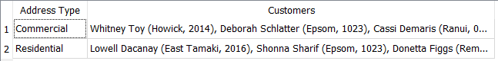

1. Write a single SQL statement to calculate the total dollar amount of all orders handled by each employee. Your output should have two columns: “Employee” and “Order Total ($)”.
2. Write a single SQL statement to calculate which suburb spent the most money with Dante’s Pizzeria. Your output should have two columns: “Suburb” and “Total ($)”.
3. Write a single SQL statement to output three columns: Employee, Status, and Time Since Hire. Employee contains the first name of each employee. Status states whether the employee is still employed or not. Time Since Hire contains the amount of time since the employee was hired (startDate) or how long the employee was hired for. Order your output by status, then, in descending order, by the time since hire. Your output should be formatted like the example below. This question is similar to the last question of the first SQL lab, if you are struggling, attempt that one first. (Note 365.25 days in a year and 30.44 days in a month).

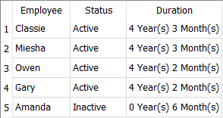

1. Select the product number, product name, product price, and the discounted price of products currently on sale
2. Calculate the total price of each order and show it as a dollar figure (i.e. $xxx)
3. List the orders with an order total over $100
4. Display the product number, product name, product price and revised price of products using the following information as a guide:

If the product contains ham: increase price by $2.00

If the product contains garlic: decrease price by $1.00

Otherwise, no changes are made to product price